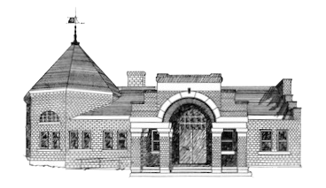

Newmarket Public Library
Trustees’ Meeting
January 10, 2023 @ 6:00 PM

- Executive Session

