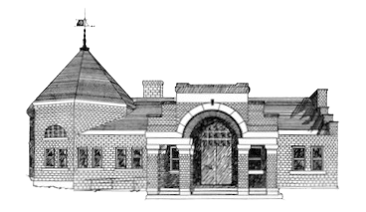

Newmarket Public Library
Trustees’ Meeting
April 24, 2023 @ 6:00 PM

- Welcome
- Friends of the NPL Report
- Approval of Minutes
- Treasurer’s Report
- Library Director’s Report
- Old Business
  - Copier Contract
  - Approval of Child Safety, Internet Access, & Programming Policies
- New Business
  - Collection Development Policy
  - Open Library Assistant Position
  - National Library Week/Volunteer Month Recognition
  - Art Displays in Library
- Suggestions for May Meeting
- Adjournment

Next meeting May 22 at 6:00 p.m.

