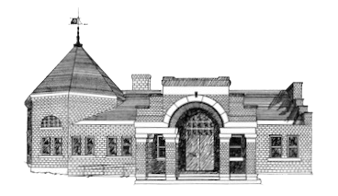

Newmarket Public Library
Trustees’ Meeting
May 22, 2023 @ 6:00 PM

- Welcome
- Friends of the NPL Report
- Approval of Minutes
- Treasurer’s Report
- Library Director’s Report
- Old Business
  - Policy Updates: Collection Development
  - Facilities Study/Feasibility Study
  - Town Resolution
  - Art Displays in Library
- New Business
  - Sharing information from NHTLA and NHLA conferences
  - Personnel Updates
- Suggestions for June Meeting
- Adjournment

Next meeting July 24 at 6:00 p.m.

