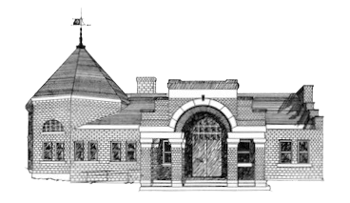

Newmarket Public Library
Trustees’ Meeting
March 27, 2023 @ 6:00 PM

- Welcome
- Reorganization of Board
- Friends of the NPL Report
- Approval of Minutes
- Treasurer’s Report
- Library Director’s Report
- Old Business
  - Approve final version of Social Media Policy
- New Business
  - Copier contract
  - April 4 reception
  - Review Internet Access Policy
  - Review Unattended Children Policy
  - Review Programming Policy
  - Recognition of Jane
  - Facilities Master Plan Questionnaire
- Suggestions for April meeting
- Adjournment

Next meeting April 24 at 6:00 p.m.

