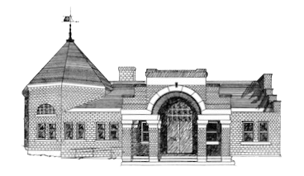

Newmarket Public Library
Trustees’ Meeting
April 22 @ 6:00 PM

- Welcome
1. Friend’s Report

2. Approval of Minutes

3. Treasurer’s Report

4. Director’s Report

5. Old Business
      - NHLTA Conference
      - Feasibility Study Update
      - Personnel Policy

6. New Business
- Trustee Board Reorganization

7. Executive Session

8. Adjournment

Next meeting TBD at 6:00 p.m.

