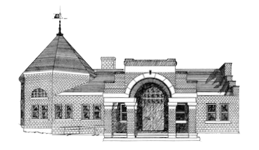

Newmarket Public Library
Trustees’ Meeting
February 21 @ 6:00 PM

- Welcome
1. Friend’s Report

2. Approval of Minutes

3. Treasurer’s Report

4. Director’s Report

5. Old Business
      - Trustee Bank Accounts
      - Request for Qualifications for Feasibility Study
      - 2025 Budget: Town Vote on March 12
      - Approval of Exhibit Policy
      - Fresh Food at the Library
      - Personnel Policy
      - Strategic Planning

6. New Business

7. Executive Session

8. Adjournment

Next meeting March 25 at 6:00 p.m.

