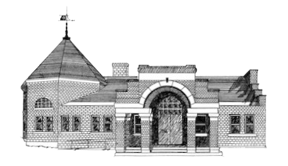

Newmarket Public Library

Trustees’ Meeting

April 7, 2025 @ 6:00 PM

1. Welcome
2. Review Minutes
3. Friends Report
4. Treasurer’s Report
5. Library Director’s Report
6. Old Business
   1. Feasibility Study Resolution
7. New Business
8. Custodian Job Posting
9. Adjournment
10. Executive Session (nonpublic)

Next meeting April 28, 2025 at 6:00 p.m.