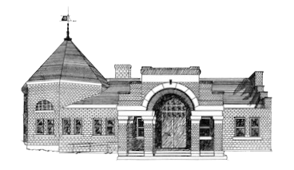

Newmarket Public Library

Trustees’ Meeting

December 6 @ 6:00 PM

**Executive Session:** Personnel